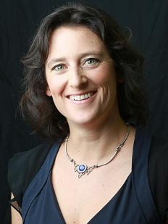
Qskeptics

Dark
Matter

Prof Tamara Davis
School of Mathematics & Physics, UQ

A multitude of observations have confirmed that the majority of matter in the universe is in a form we can’t see. That “Dark Matter" provides the gravitational scaffolding on which all the galaxies and clusters of galaxies are built. However, we still don’t know what it might be.
This talk will present the vast array of different types of measurements that have revealed the presence of dark matter. We will look at what we have be able to infer about its properties, and discuss how we are continuing observations and tests to figure out exactly what it is. These include dark matter detectors built deep in mines, both overseas and here in Australia, as well as dark matter observations probing deep space, such as the recent Dark Energy Survey data that made the most detailed map of the distribution of dark matter ever made: https://theconversation.com/what-a-new-map-of-the-universe-tells-us-about-dark-matter-82074 .
Meanwhile we’ll also look at cases where dark matter doesn’t seem to be behaving as we expect, for example in the cluster of galaxies "Abell 520”, and what that might imply about dark matter in all its complexity.
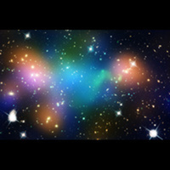

Monday 25th September 2017
The Morrison Hotel
640 Stanley St, Woolloongabba QLD (07-3391 1413)
6pm Dinner 7:30pm meeting
Abell 520 text by TD

